Progress Report
Jianan Wen 001678266
Zixuan Xu 001224785
Wenbo Sun 001994516

FaceBook public information capture, analysis, and classification by using ML
FaceBook as one of the most popular social media, have millions users sharing information them of their life every day. What information could we know from that? How well can we know them by that? What kind of information could be expose through that? To analyse the data form Facebook, we are dealing with image, video, text, landmark, time of activity, and network. In that project we are going to use Principal Component Analysis, K-mean, cluster or classification, Naive Bay Classifier, ANN, other unsupervised machine learning technique to capture, analysis, and finally classify a person to a type of charater.
Plan changing:
We use Facebook graph API to get those raw data from Facebook. However, Facebook only allows the extraction of information published on user’s own home page, or content published on public accounts. So we can not get data from personal account. We can only get data from public account, for example, some company like Steam and Google.
So, instead of personal charater analysis, we will do company public data analysis.
Progress:
We are not using any existed data, we wrote code to generate our own data.
Step1:get the raw data
We use Facebook Graph API to get those data. This is the code:

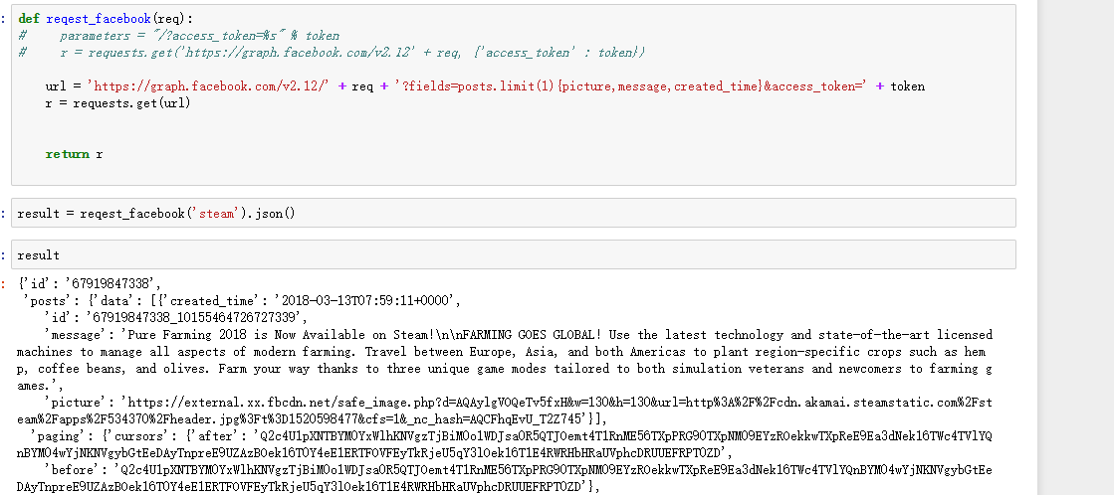

And this is the result:
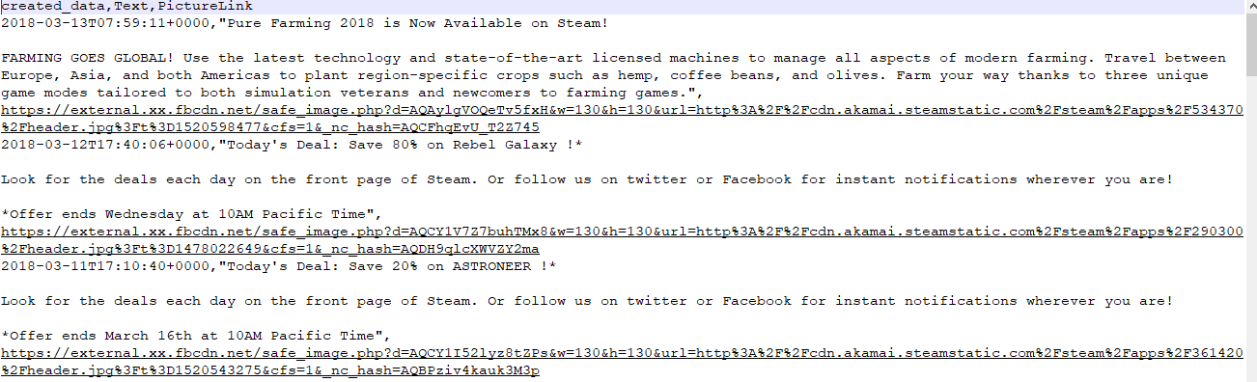
It is in csv format. Each row is a post. Columns are: time, text, and the url to the picture.
Step2: process images.
We are using Google vision API to process images. Because the Facebook image url is in a special format and Google API can not use it, we have to download each image to local, then analyse, and delete it. Here is the code we use to download image from Facebook url:
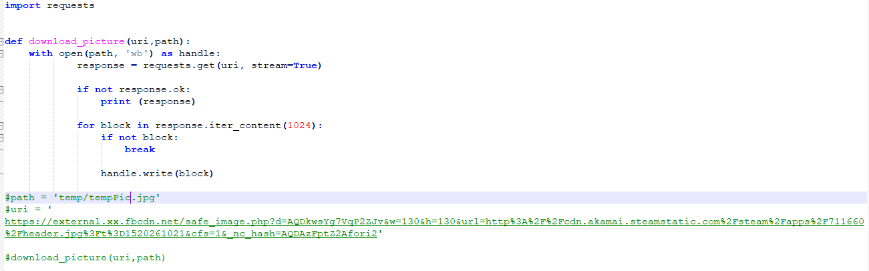
Then we can feed the image to Google API. After we do that, we will get a list of key word, landmark, and emotion. We are going to have a filter to remove the word we do not want. Here is the code for Google API:
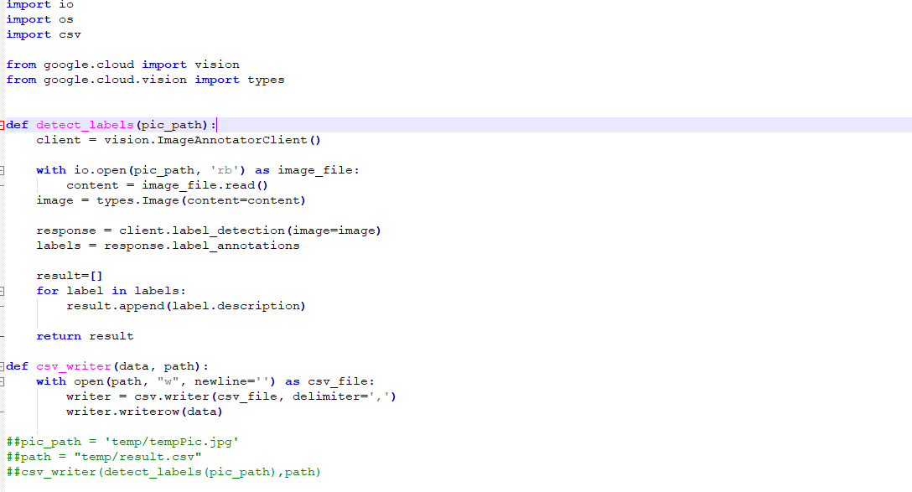
Step3: text analysis
We also process the text. By using Rake libeary, we transform text to labels, here is the code:

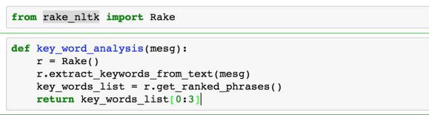
Here is the result:
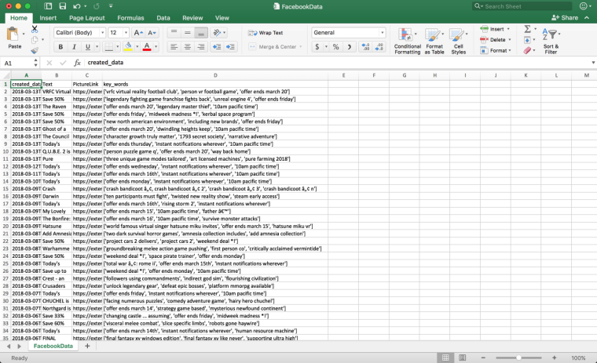

Summary and plan:
What we did so far is basically transform everything abstract into keyword, label and measurable value. It take us half minute to process 100 posts. So our data is streaming.
We are not yet have a very special plan about what are we going to do with those data. Because our initial plan is to do personal charater analysis on personal post. Now we can only get public post. So, we want to do the same kind of analysis on company, like what is the type of the company, what is their business, and how does everyone like them.

Algorithms
Naive Bay Classifier for sentiment analysis:
https://streamhacker.com/2010/05/10/text-classification-sentiment-analysis-naive-bayes-classifier/
Neural Network Classification: https://www.solver.com/xlminer/help/neural-networks-classification-intro
Google visual API
https://cloud.google.com/vision
Rapid Automatic Keyword Extraction algorithm using NLTK.
https://github.com/csurfer/rake-nltk
Facebook graph API
https://developers.facebook.com/docs/graph-api/

Reference:
Neural Network Classification https://www.solver.com/xlminer/help/neural-networks-classification-intro
TEXT CLASSIFICATION FOR SENTIMENT ANALYSIS – NAIVE BAYES CLASSIFIER https://streamhacker.com/2010/05/10/text-classification-sentiment-analysis-naive-bayes-classifier/
Abdul Majid , Ling Chen , Gencai Chen , Hamid Turab Mirza , Ibrar Hussain & John Woodward, A context-aware personalized travel recommendation system based on geotagged social media data mining
Google visual API
https://cloud.google.com/vision

